Chapter 2 People’s as resources

Introduction:-

* ‘*Peoples are resources*’ as resource is a way of referring to a country’s working people in terms of their existing productive skills and abilities.
* Investment in human capital (through) education, training, medical care yields just like investment in physical capital. This can be seen directly in the form of higher incomes earned because of higher productivity of the more educated or the better trained persons, as well as the higher productivity of healthier people.
* One Example :- Green Revolution and The IT Revolution –
* In green Revolution dramatic example is how the input in earlier days before 1960 then the modern techniques after 1960 gives a boom production in the primary sector this helps in economy of the country in way that the India can sell the grains to other countries of the world like – Japan and Arab countries like UAE and Somali and Sell in own country.
* In IT Revolution the education is given most importance. Citizens can create Software and new Technology and sell it to other countries. E.g.:- Paytm and USB Cables are some App’s and Technology which was created by the citizens of our country and this was used in numbers in the world. This also helps in the Economy of the country.
* In both Revolution the IT sector Annual Income is more than the Green Revolution
* Assets: - Assets are the things which help to earn money from them e g: - Stocks, Land, Machine, Cars.
* Liability: - Liabilities are the things which did not earn money for you Instead they spend your money to maintains of that thing e g: - Bike/Car for personal Use. Buying Machines instead of taking it on rent
* Conclusion: - Over a large period of time the population of India is used as Liabilities but rather we can change these Liabilities into assets by Taking more focus and investment in the (Education, medical) sector and training. This help the youth to use modern agriculture techniques and Work in IT Sector which can help to get a higher income and this effects also to the Economy of the country

Story of Sakal and Vilas

* Sakal

There was a small village in which a boy name Sakal Buta Chaudhary lives. His Father name was Buta Chaudhary and Mother Name is Sheela. His father worked in the Fields and His mother Was a Housewife do Domestic chores like (Preparing Meals for Family, Taking care of children’s) etc. Sakal Helps his mother and Take care of his Brother and Sister’s. His Parent’s forced him to go to local village school. Sakal Agreed to go to the school because He has a vigour (Energy) and Enthusiasm (Interest) in the Studies. So he joins the school and Complete his Studies. After his father takes a loan for Sakal higher education because Sakal was interested in the study. After sometime he joined a private firm and create a software which was increase the sale of the firm because of Sakal this achievement his boss give him a promotion. He has a good source of income and he raised his family slandered of living and contribute and a better citizen to the country

* Vilas

Vilas was an 11 year boy lived in the same village like in Sakal. When he was 2 years old his Father passed away. His mother Geeta started to take caring of him. Geeta do fishing in a landowner’s pond.

He sold the caught fishes in the market. He Earn only 150 Rs per day. Vilas has a medical problem when he was old But Geeta did not show it to doctor because she cannot hired the purchase of the medical and doctor’s fees so Vilas started become sick. Vilas help her mother at cooking and take care of his brother. From Earlier Vilas did not have Interest in the studies because he didn’t go to school? After few years his mother started becoming sick. Then there is no any family member to see on him. Later Vilas was forced to caught & sell fish.

* Theory

In both stories you can see that, Sakal Live a good life with a good income and Vilas didn’t live a good life with an insufficient income 150 Rs per days means 4500 monthly income but both these boys are lived in the same village and some same family problems. These because the Sakal parents have send Sakal to schools and Take loan for higher Education and take care of the health. This help in Sakal (Education and Medical) development in his life and Sakal has a enthusiasm and vigour in the studies on the other hand Vilas mother did not forced to Vilas to go to school and didn’t take care on the Health of the Vilas and Vilas did not have much interest in the studies. These reasons are there in which Sakal Lived a better life and Vilas rather belonging to same village.

* Conclusion
* Investment in the (Health and Medical) Sector mostly return a good return.
* These also help to contribute in the Country as a citizen.

Three Sectors of Activities in Economy

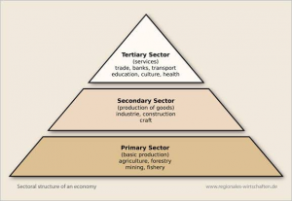

1. Primary Activity

* Raw material used in the Manufacturing comes from the Primary Sector.
* E g: - Farms Products, Dairy Products, Animal Husbandry, Poultry Farming, Fishing etc. are all the activities come under the Primary activity.

1. Secondary Activity

* Raw Material come from the ***Primary Activity*** is Manufacture in the Secondary Activity.
* Secondary output is Goods and Services
* E g: - Mining and Quarrying and Manufacturing.

1. Tertiary Activity

* Goods and Services come from the ***Secondary Activity*** transported, traded, doing all banking activities comes under Tertiary Activity.
* Traders buy the goods from the factory and transport it to the market in which it was sold in the market by the shopkeeper.
* E g: - Transportation, Trading, Banking etc.
* Theory

The Raw material came from the Fields was manufacture in the factories and change raw material into a goods or a service which was used by the citizen’s the Service and goods was transported to the cities by the trader or to village by small traders to the village here these goods are they were sold by the shopkeepers of the cities. In these all Steps the economy of the country also rises

Virtuous Cycle & Vicious cycle

* Virtuous cycle is known as educated people generation has a Good Education and health then this generation gives these resources to their generation. These is how this cycle worked

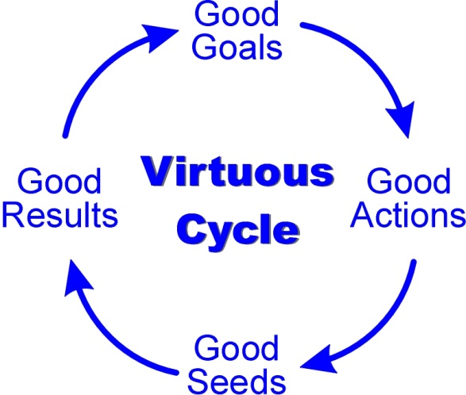

Diagram of Virtuous Cycle

* Vicious cycle is a cycle in which the less educated did not give proper education and health to their generation so this generation did not knows the benefits of these resources. So, this generation can’t give this information about these resources to their generation. These is how Vicious cycle work. In few cases Vicious cycle peoples their generation can knows these advantages of these resources so they adopted these resources so then jumped into virtuous cycle from the vicious cycle.

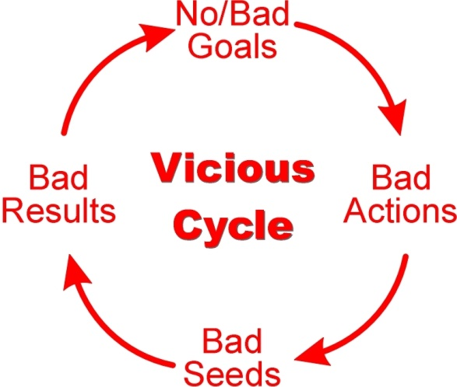

Economies Activities by Men and Woman

* From the Historian and the cultures of the India we can get to know that a man works as a labour and woman take care of the house. Always men’s Job was got more importance than woman. In earlier days woman’s Job was to domestic chores.
* In the story we can also see that Sakal mother work in home as domestic chores which did not affect the annual income but Sakal father work’s in the field which affect the annual income of the country. In Vilas case it was another issue. No, any person to do the constant support of income in the family because his father passed away when he was just 2 year’s old
* Education and skills are the needs of the earning of the money
* Most women have meagre(less) amount of education so this also affect in the wages of the job. They got paid less wages for their Job.
* Most woman work in the fields where security facility is not good.
* No , Maternity Leave (Pregnancy) and childcare
* Woman with higher education work as a job in which woman also get paid same wages as the man
* Woman mostly found in organised sector like medical, teaching.
* Nowadays, Woman also gets enrolled in administrative at high levels and scientific and technological competence.

Quality of Population

* The quality of Population depends upon the literacy rate and health care and skills.
* The Literate and healthy people become as assets for the country and sick and Uneducated or less educated and without any skill become a liability to the country or as Burden.

1. Education

* Education is a basic need for every citizen of the country also Education is also in the human rights.
* Government have taken several steps to :

1. Providing universal access(Nearby schools) to the children’s and above 18th student and Quality of elementary education with most focused on girls

* A Mahatma Gandhi quote was :-

If you teach a boy you only teach a boy but if you teach a girl you teach a whole family

1. There is also establishing schools like “Navodaya Vidyalaya“
2. Vocational training’s should be enforced
3. In first year plan the education sector budget was 151 crore and in 11 year plan education sector budget was 3766 crore.

Outcomes

* The literacy rate has grown. Now 78 % of India is educated.
* This help to enjoy their rights.
* 8 lakhs schools were built which give employment to the citizens
* “Mid-day Meal” scheme make children comes schools daily and also Maintain the health of the children
* “Sarva Siksha Abhiyan” forced parents to send children to school from 6 yrs. To 14 yrs. and protect child from work as labour on the building sites.

Problems

* 8 lakhs schools were built but there is no quality of education.
* In Ed sector the government said that there is 6 % of budget in Ed but only 3 % are there.
* No proper curriculum (Method of teaching).
* No students regularly attending school but there is “Mid-day meal program” which also forced children to attend the school